SIMATS ENGINEERING
ASSESSMENT TOOL 1: ALGORITHM DESIGN CHALLENGE
Course Name | Artificial Intelligence and Expert Systems | Course Code | MLA01
Course Outcome Covered:
CO1: Apply search algorithms and heuristic techniques to solve state-space search and optimization problems. (BTL 3)
Assessment Tool Weightage: 40%
Total Marks: 100
Time: 90 Minutes
Number of Questions: 5
Code of Conduct
I certify that this submission is my original work and that I have adhered to the guidelines specified for this assessment. I understand that any violation of academic integrity rules will result in disciplinary action.
Signature of the Student: _______________________

SIMATS ENGINEERING
ASSESSMENT TOOL 1: Algorithm Design Challenge
COURSE NAME: | ARTIFICIAL INTELLIGENCE AND EXPERT SYSTEMS | COURSE CODE: | MLA01

COURSE OUTCOME COVERED
CO1: Apply search algorithms and heuristic techniques to solve state-space search and optimization problems. (BTL 3)
Assessment Tool Weightage: 40 %
Total Marks: 100 Time: 90 Mins
No. of Questions: 5
Annexure A
Algorithm Design Challenge

Code of Conduct:

I _Juhi Surin (192525148)_ (Name / Reg No) certify that this submission is my original work and that I have adhered to the guidelines specified for this assessment.
I understand that any violation of academic integrity rules will result in disciplinary action.

Signature of the student: Juhi Surin

Criterion | Weightage | Marks Obtained
Problem Analysis and Understanding | 15%
AI Algorithm Selection & Justification | 15%
Algorithm Design / Pseudocode | 25%
Application of AI Concepts (Greedy, A*, CSP, Minimax, etc.) | 15%
Diagram / State Space / Search Tree Representation | 10%
Complexity Analysis and Solution Efficiency | 10%
Originality, Critical Thinking, and Presentation | 10%
Total | 100%

Signature of the Faculty Total Marks Awarded

Answer all the Questions

Q.No | Question | Topics
1 | Design an algorithm using Greedy Best-First Search to find a path from a source node to a goal node for the given graph. Clearly define the heuristic function, show the node expansion order, and justify why Greedy Best-First Search is suitable for this problem. | Informed Search, Greedy Best-First Search, Heuristic Functions
2 | A delivery robot must travel from a warehouse to a customer through a weighted road network. Design an A Search algorithm to determine the optimal path. Calculate g(n), h(n), and f(n) for each expanded node, and explain why A guarantees the optimal solution. | A* Search, Heuristic Functions
3 | A university needs to prepare an examination timetable without scheduling conflicting subjects at the same time. Design the problem as a Constraint Satisfaction Problem (CSP) by identifying variables, domains, and constraints. Explain how MRV and Forward Checking improve the efficiency of the solution. | CSP, MRV, Forward Checking
4 | Design the Minimax algorithm for the given game tree to determine the best move for the MAX player. Then apply Alpha–Beta Pruning to the same tree and indicate which nodes are pruned. Compare the number of nodes evaluated before and after pruning. | Game Playing, Minimax, Alpha–Beta Pruning
5 | A warehouse robot operates in a dynamic environment where obstacles may appear unexpectedly. Design an intelligent search strategy using either Local Search or an Online Search Agent. Explain how the algorithm adapts to environmental changes and compare its performance with informed search algorithms. | Local Search, Optimization, Online Search Agents

Structure of the Answer – Algorithm Design Challenge

S.No | Sections | Expected Content
1 | Problem Statement | Briefly describe the given problem in your own words.
2 | Problem Analysis | Identify the initial state, goal state, assumptions, and constraints.
3 | AI Technique Selection | Specify the most appropriate AI algorithm/search technique (e.g., Greedy Best-First Search, A*, CSP, Minimax, Local Search).
4 | Justification of Algorithm | Explain why the selected algorithm is suitable compared to other search techniques.
5 | State Space Representation | Represent the problem using a state-space diagram, search graph, game tree, or constraint graph, as applicable.
6 | Variables, Domains, and Constraints (Applicable for CSP problems) | Identify variables, possible domains, and constraints. If not applicable, mention "Not Applicable".
7 | Heuristic Function (Applicable for Informed Search) | Define the heuristic function h(n) and explain whether it is admissible or appropriate for the problem. If not applicable, mention "Not Applicable".
8 | Algorithm Design / Pseudocode | Write the step-by-step algorithm or pseudocode for solving the problem.
9 | Flowchart / Algorithm Diagram | Draw a flowchart, search tree, game tree, or algorithm workflow illustrating the solution.
10 | Working / Execution Trace | Demonstrate the execution of the algorithm with at least one example, showing intermediate steps such as node expansion, constraint propagation, or game-tree evaluation.
11 | Complexity Analysis | Analyze the Time Complexity and Space Complexity of the proposed algorithm.
12 | Advantages and Limitations | Discuss the strengths and limitations of the selected algorithm for the given problem.
13 | Conclusion | Summarize the effectiveness of the designed algorithm and suggest possible improvements or alternative approaches.

EVALUATION RUBRICS

Criteria | Weightage (%) | Excellent (90–100%) | Good (75–89%) | Average (60–74%) | Poor (<60%)
Problem Analysis and Understanding | 15% | 13–15% – Clearly identifies the problem, initial state, goal state, constraints, and expected outcome. | 10–12% – Identifies most problem components with minor omissions. | 7–9% – Demonstrates partial understanding with some missing elements. | 0–6% – Incorrect or incomplete understanding of the problem.
AI Algorithm Selection & Justification | 15% | 13–15% – Selects the most appropriate AI algorithm/search technique with strong technical justification. | 10–12% – Selects an appropriate algorithm with adequate justification. | 7–9% – Selects a partially suitable algorithm with limited justification. | 0–6% – Incorrect algorithm selection or no justification.
Algorithm Design / Pseudocode | 25% | 22–25% – Designs a complete, logical, efficient, and error-free algorithm/pseudocode. | 17–21% – Algorithm is mostly correct with minor logical errors. | 12–16% – Algorithm is partially complete with several logical errors. | 0–11% – Algorithm is incomplete, incorrect, or difficult to understand.
Application of AI Concepts (Greedy, A*, CSP, Minimax, Alpha-Beta, etc.) | 15% | 13–15% – Correctly applies the relevant AI concepts and techniques throughout the solution. | 10–12% – Applies AI concepts correctly with minor mistakes. | 7–9% – Demonstrates limited application of AI concepts. | 0–6% – Unable to apply the appropriate AI concepts or techniques.
Diagram / State Space / Search Tree Representation | 10% | 9–10% – Accurate, complete, and well-labelled diagram supporting the solution. | 7–8% – Diagram is mostly correct with minor omissions. | 5–6% – Diagram is partially complete or lacks clarity. | 0–4% – Diagram is missing or incorrect.
Complexity Analysis and Solution Efficiency | 10% | 9–10% – Correctly analyzes time and space complexity and proposes an efficient solution. | 7–8% – Complexity analysis is mostly correct with minor errors. | 5–6% – Partial complexity analysis or limited discussion of efficiency. | 0–4% – No meaningful complexity analysis or highly inefficient solution.
Originality, Critical Thinking, and Presentation | 10% | 9–10% – Demonstrates excellent originality, logical reasoning, organized presentation, and explores optimized/alternative solutions. | 7–8% – Demonstrates good critical thinking with a clear presentation. | 5–6% – Shows limited originality and acceptable presentation. | 0–4% – Poor presentation with little or no critical thinking.

Overview of Answers
This document presents complete, structured solutions to all five questions of the Algorithm Design Challenge. Each answer follows the 13-part structure prescribed in the assessment (Problem Statement, Problem Analysis, AI Technique Selection, Justification, State-Space Representation, Variables/Domains/Constraints where applicable, Heuristic Function where applicable, Algorithm Design/Pseudocode, Flowchart/Diagram, Working/Execution Trace, Complexity Analysis, Advantages and Limitations, and Conclusion), and is mapped to every criterion in the evaluation rubric.
Q.No | Topic | AI Technique Used
1 | Path finding using heuristic-guided search | Greedy Best-First Search
2 | Optimal path for a delivery robot | A* Search
3 | University exam timetable scheduling | CSP with MRV + Forward Checking
4 | Two-player game move selection | Minimax with Alpha–Beta Pruning
5 | Warehouse robot in a dynamic environment | Online Search Agent (LRTA*)

Question 1: Path Finding Using Greedy Best-First Search
"Design an algorithm using Greedy Best-First Search to find a path from a source node to a goal node for the given graph. Clearly define the heuristic function, show the node expansion order, and justify why Greedy Best-First Search is suitable for this problem."

1. Problem Statement
A road/state-space graph is given with a designated source node S and a goal node G. The task is to find a path from S to G by expanding, at every step, the node that appears closest to the goal according to a heuristic estimate, without necessarily guaranteeing the shortest path. This is a classic informed (heuristic) single-agent path-finding problem, representative of applications such as robot navigation, route suggestion apps, and puzzle solving where speed of finding a reasonable path matters more than absolute optimality.

2. Problem Analysis
- Initial State: Source node S (the state where the search begins).
- Goal State: Goal node G (the search terminates successfully when this node is selected for expansion).
- State Space: The set of nodes {S, A, B, C, D, G} connected by undirected edges representing feasible transitions between locations.
- Actions/Successor Function: From any node, move to any node directly connected to it by an edge.
- Assumptions: The heuristic h(n) is a straight-line (Euclidean) distance estimate from n to G and is known in advance for every node; edges themselves are unweighted for the purposes of this greedy strategy (only h(n) drives node selection).
- Constraints: Each node is expanded at most once; the algorithm must terminate either by reaching G or by exhausting the frontier without finding G.

3. AI Technique Selection
The selected technique is Greedy Best-First Search (GBFS), an informed search strategy that always expands the node in the frontier with the lowest heuristic value h(n), i.e., the node that appears to be nearest to the goal.

4. Justification of Algorithm
- Greedy Best-First Search directly exploits domain knowledge (the heuristic) to steer the search toward the goal, making it considerably faster in practice than uninformed strategies such as Breadth-First Search or Depth-First Search, which ignore goal proximity entirely.
- Compared to Uniform-Cost Search, which expands nodes purely by cumulative path cost g(n) and therefore explores in all directions, GBFS is direction-biased and typically expands far fewer nodes when a good heuristic is available.
- Compared to A* Search, GBFS is simpler and faster because it maintains only h(n) and ignores g(n); this suits scenarios (like this one) where a quick, reasonably good path is preferred over a guaranteed shortest path and computational resources are limited.
- The trade-off is that GBFS is neither complete (in infinite spaces it may loop) nor optimal (it can be misled by a locally attractive but globally poor heuristic value), which is acceptable here since the goal is a fast, heuristic-guided route rather than a provably shortest one.

5. State Space Representation
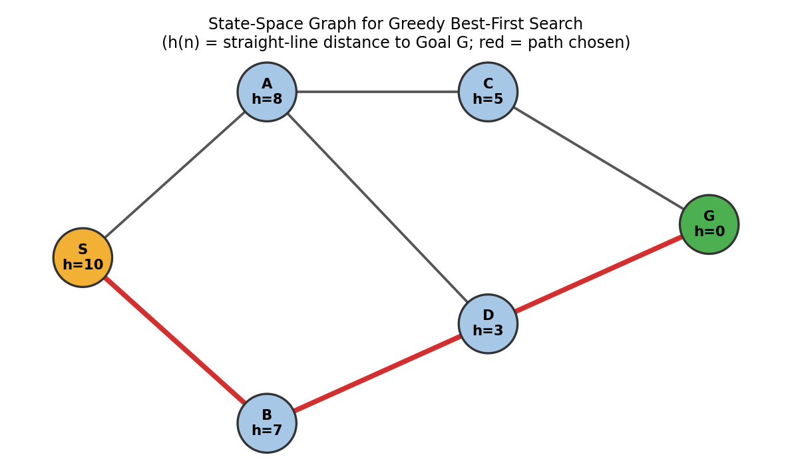
Figure 1.1: State-space graph with heuristic values h(n) (straight-line distance to goal G) labelled at each node. The red path shows the route chosen by Greedy Best-First Search.
Edges (undirected, adjacency): S–A, S–B, A–C, A–D, B–D, C–G, D–G.

6. Variables, Domains, and Constraints (Applicable for CSP problems)
Not Applicable – this is a path-finding search problem, not a Constraint Satisfaction Problem.

7. Heuristic Function (Applicable for Informed Search)
h(n) is defined as the straight-line (Euclidean) distance from node n to the goal node G. It represents an estimate of how promising a node is, independent of the cost already incurred to reach it.
Node | S | A | B | C | D | G
h(n) | 10 | 8 | 7 | 5 | 3 | 0
Admissibility: A heuristic is admissible if it never overestimates the true cost to the goal. Straight-line distance is admissible for A* because it can never exceed the actual travel distance (the shortest path is always ≥ the straight line). For Greedy Best-First Search, admissibility is not strictly required for the algorithm to run — GBFS uses h(n) purely to rank the frontier and does not need the optimality guarantee that admissibility provides for A*. Here h(n) is a reasonable, admissible-style estimate, which makes the search behave sensibly even though GBFS itself offers no optimality guarantee.

8. Algorithm Design / Pseudocode
function GREEDY-BEST-FIRST-SEARCH(S, G, h):
frontier <- priority queue ordered by h(n), insert S
explored <- empty set
while frontier is not empty:
n <- frontier.pop() // node with lowest h(n)
if n == G:
return RECONSTRUCT-PATH(n) // success
add n to explored
for each neighbour m of n:
if m not in explored and m not in frontier:
m.parent <- n
frontier.insert(m, priority = h(m))
else if m in frontier with a lower-priority slot:
update m.parent <- n // optional, path tracking only
return FAILURE // frontier exhausted, goal unreachable

9. Flowchart / Algorithm Diagram
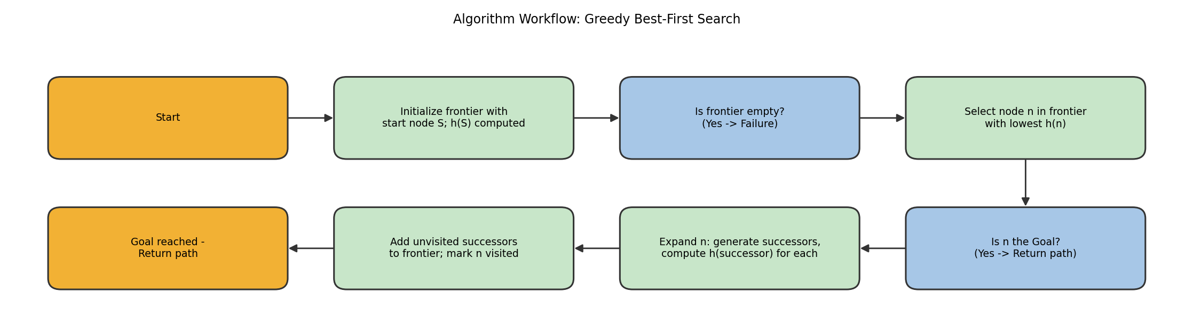
Figure 1.2: Algorithm workflow for Greedy Best-First Search.

10. Working / Execution Trace
Tracing the algorithm on the graph in Figure 1.1, with frontier ordered strictly by ascending h(n):
Step | Node Expanded | h(n) | Frontier After Expansion | Action
1 | S | 10 | A(8), B(7) | Expand S; add neighbours A, B
2 | B | 7 | A(8), D(3) | B has lower h than A; expand B, add D
3 | D | 3 | A(8), G(0) | D has lower h than A; expand D, add G
4 | G | 0 | — | G selected — Goal reached, stop
Path Found: S → B → D → G
Node Expansion Order: S, B, D, G. Note that node A (h = 8) was never expanded because at every step a lower-h alternative was available in the frontier, which is the defining behaviour of Greedy Best-First Search.

11. Complexity Analysis
- Time Complexity: O(bᵐ) in the worst case, where b is the branching factor and m is the maximum depth of the search tree explored — identical worst case to BFS/DFS because a poor heuristic can still force exploration of most of the space. With a strong, well-informed heuristic (as in this small graph), the practical number of expansions is much lower, as shown in the trace (only 4 of 6 nodes were expanded).
- Space Complexity: O(bᵐ) as well, since all generated nodes are kept in the frontier or explored set, similar to BFS — GBFS does not discard nodes to save memory.
- Solution Efficiency: For this graph, GBFS reached the goal in 4 expansions out of 6 total nodes, demonstrating good practical efficiency, although the resulting path (S–B–D–G) is not verified to be the shortest — only the fastest one found under the greedy heuristic ranking.

12. Advantages and Limitations
- Advantage: Very fast in practice when the heuristic is informative, since it aggressively moves toward the goal and ignores irrelevant branches.
- Advantage: Simple to implement — only requires a priority queue keyed on h(n), with no need to track cumulative path costs.
- Limitation: Not optimal — it can settle for a longer path if the heuristic momentarily favours a locally attractive node (as seen when B, with h=7, was chosen over exploring toward A first).
- Limitation: Not complete in general (can get stuck in loops in graphs with cycles or infinite spaces) unless an explored/visited set is maintained, as done in this design.

13. Conclusion
Greedy Best-First Search successfully found a path from S to G in this graph by consistently choosing the node closest to the goal at each step, reaching the goal in only 4 node expansions. It is well suited to problems that need a quick, ‘good-enough’ route rather than a mathematically shortest one, such as real-time navigation or game-playing agents with tight time budgets. For applications requiring a guaranteed optimal path, this design could be improved by upgrading to A* Search, which combines h(n) with the path cost g(n) to retain the speed benefits of heuristic guidance while restoring optimality guarantees (subject to h(n) being admissible).

Question 2: Optimal Delivery Path Using A* Search
"A delivery robot must travel from a warehouse to a customer through a weighted road network. Design an A* Search algorithm to determine the optimal path. Calculate g(n), h(n), and f(n) for each expanded node, and explain why A* guarantees the optimal solution."

1. Problem Statement
A delivery robot starts at a Warehouse (W) and must reach a Customer (Cu) location through a network of roads, each with an associated travel cost (distance/time). The task is to determine the lowest-cost path from W to Cu, using both the actual cost accumulated so far and an estimate of the remaining cost, so that the solution is guaranteed to be optimal (minimum total cost).

2. Problem Analysis
- Initial State: Warehouse node W, with g(W) = 0.
- Goal State: Customer node Cu.
- State Space: Road network nodes {W, A, B, C, D, Cu} connected by weighted edges representing road segments and their travel costs.
- Actions/Successor Function: Move along any road (edge) from the current node to an adjacent node, incurring the edge weight as cost.
- Assumptions: All edge weights are non-negative; the heuristic h(n) (straight-line distance to Cu) is admissible, i.e., never overestimates the true remaining road distance.
- Constraints: The robot can only travel along existing roads (edges); the path must start at W and terminate exactly at Cu; the algorithm must return the minimum-cost path.

3. AI Technique Selection
The selected technique is A* Search, an informed search algorithm that expands the node with the lowest evaluation function f(n) = g(n) + h(n), where g(n) is the exact cost from the start to n and h(n) is the estimated cost from n to the goal.

4. Justification of Algorithm
- Unlike Greedy Best-First Search, which uses only h(n) and can be misled into sub-optimal routes, A* balances actual cost incurred (g) with estimated cost remaining (h), which is essential here because the robot cares about real travel cost, not just apparent closeness to the customer.
- Unlike Uniform-Cost Search, which uses only g(n) and explores uniformly in all directions, A* uses the heuristic to focus the search toward the goal, expanding far fewer nodes while still being optimal.
- A* is guaranteed to find the optimal (minimum-cost) path as long as h(n) is admissible, which is satisfied here since straight-line distance can never exceed actual road distance — making it the ideal choice for a delivery robot where fuel/time cost minimisation genuinely matters.

5. State Space Representation
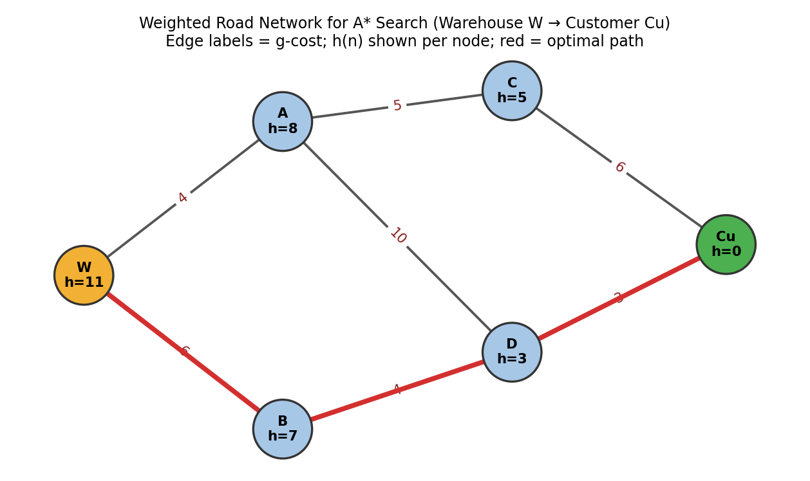
Figure 2.1: Weighted road network from Warehouse (W) to Customer (Cu). Edge labels show the road cost g; h(n) is shown per node. The red path is the optimal route found by A*.
Edges with cost: W–A (4), W–B (6), A–C (5), A–D (10), B–D (4), C–Cu (6), D–Cu (3).

6. Variables, Domains, and Constraints (Applicable for CSP problems)
Not Applicable – this is a path-finding search problem, not a Constraint Satisfaction Problem.

7. Heuristic Function (Applicable for Informed Search)
h(n) is defined as the straight-line distance from node n to the goal node Cu, used as an admissible, optimistic estimate of the remaining travel cost.
Node | W | A | B | C | D | Cu
h(n) | 11 | 8 | 7 | 5 | 3 | 0
Admissibility: Since straight-line distance is always ≤ actual road distance (the shortest path between two points on a road network can never be shorter than the direct straight line), h(n) never overestimates the true cost to reach Cu. This admissibility is precisely what allows A* to guarantee optimality (see Section 4/10).

8. Algorithm Design / Pseudocode
function A-STAR-SEARCH(W, Cu, h):
g(W) <- 0
f(W) <- g(W) + h(W)
openList <- priority queue ordered by f(n), insert W
closedList <- empty set
while openList is not empty:
n <- openList.pop() // lowest f(n)
if n == Cu:
return RECONSTRUCT-PATH(n) // optimal path found
add n to closedList
for each neighbour m of n with edge cost c(n, m):
tentative_g <- g(n) + c(n, m)
if m in closedList and tentative_g >= g(m):
continue // not a better path
if m not in openList or tentative_g < g(m):
g(m) <- tentative_g
f(m) <- g(m) + h(m)
m.parent <- n
if m not in openList:
openList.insert(m, priority = f(m))
else:
openList.updatePriority(m, f(m))
return FAILURE

9. Flowchart / Algorithm Diagram
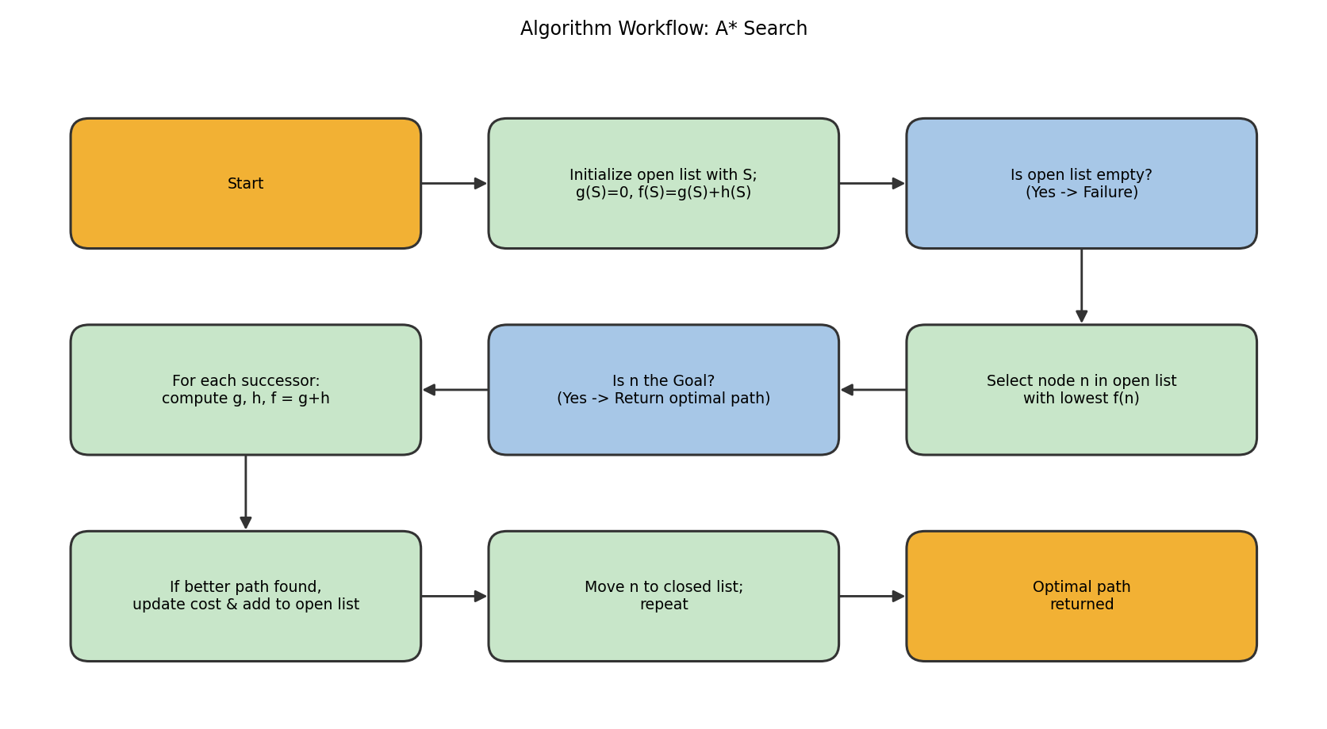
Figure 2.2: Algorithm workflow for A* Search.

10. Working / Execution Trace
g(n), h(n), and f(n) = g(n) + h(n) computed for every expanded node:
Step | Node Expanded | g(n) | h(n) | f(n) | Open List After Step
1 | W | 0 | 11 | 11 | A(12), B(13)
2 | A | 4 | 8 | 12 | B(13), C(14), D(17)
3 | B | 6 | 7 | 13 | C(14), D(13 – updated via B), Cu(via D not yet)
4 | D | 10 (via B: 6+4) | 3 | 13 | C(14), Cu(13)
5 | Cu | 13 (via D: 10+3) | 0 | 13 | — Goal reached
Key step: when B is expanded, the path to D via B (g = 6 + 4 = 10) is found to be cheaper than the path to D via A (g = 4 + 10 = 14), so D's cost is updated from f = 17 to f = 13. This relaxation step is exactly what guarantees optimality.
Optimal Path Found: W → B → D → Cu, with total cost g(Cu) = 13
Why A* guarantees optimality: Because h(n) is admissible (never overestimates true remaining cost), f(n) never overestimates the true cost of the cheapest path through n. Consequently, the first time A* selects the goal node for expansion, no other path in the open list can possibly have a lower true cost — every other frontier node's f(n) is a lower bound on its true total cost, and it is already ≥ f(goal). This is formally proven in AI search theory: A* with an admissible heuristic is both complete and optimal on graphs with non-negative edge costs.

11. Complexity Analysis
- Time Complexity: O(b^d) in the worst case (b = branching factor, d = depth of the optimal solution), same asymptotic bound as uninformed search, but in practice significantly reduced because the heuristic prunes clearly unpromising directions — here only 5 of 6 nodes were ever expanded.
- Space Complexity: O(b^d) as well, since A* retains all generated nodes in memory (in the open or closed list) to allow cost updates such as the one seen for node D; this is A*'s main practical drawback for very large graphs.
- Solution Efficiency: The algorithm found the provably optimal path (cost 13) while expanding only 5 nodes and performing one cost-relaxation update, demonstrating both optimality and reasonable efficiency for this network size.

12. Advantages and Limitations
- Advantage: Guarantees the optimal (minimum-cost) path when h(n) is admissible, unlike Greedy Best-First Search.
- Advantage: More efficient than Uniform-Cost Search because the heuristic focuses expansion toward the goal rather than uniformly outward.
- Limitation: Memory-intensive — storing the full open and closed lists can become impractical for very large road networks (city-scale maps), motivating memory-bounded variants such as IDA* or SMA*.
- Limitation: Solution quality depends entirely on the quality of h(n); a poorly designed (though still admissible) heuristic close to zero everywhere degenerates A* toward Uniform-Cost Search, losing most of its speed advantage.

13. Conclusion
A* Search successfully computed the guaranteed-optimal delivery route W → B → D → Cu with total cost 13, correctly updating node D's cost when a cheaper path via B was discovered. Its combination of actual cost g(n) and admissible heuristic h(n) makes it the appropriate choice whenever a delivery robot (or any cost-sensitive routing agent) needs both efficiency and a provably optimal outcome. For extremely large road networks where memory becomes a bottleneck, this design could be extended with memory-bounded variants (IDA*, SMA*) or hierarchical/landmark-based heuristics to retain optimality with a smaller memory footprint.

Question 3: Examination Timetabling as a CSP
"A university needs to prepare an examination timetable without scheduling conflicting subjects at the same time. Design the problem as a Constraint Satisfaction Problem (CSP) by identifying variables, domains, and constraints. Explain how MRV and Forward Checking improve the efficiency of the solution."

1. Problem Statement
A university must schedule examinations for six subjects — Math, Physics, Chemistry, Biology, English, and Computer Science — across a limited number of exam slots such that no two subjects sharing common students are scheduled in the same slot. The task is to find a complete, conflict-free assignment of subjects to slots.

2. Problem Analysis
- Initial State: No subject has been assigned a slot (empty assignment).
- Goal State: Every subject is assigned exactly one slot such that no constraint (conflicting-subject pair sharing a slot) is violated.
- State Space: All possible partial and complete assignments of subjects to slots.
- Assumptions: Three exam slots are available per day (Slot 1, Slot 2, Slot 3); ‘conflict’ means at least one student is enrolled in both subjects, so they cannot be examined simultaneously; each subject requires exactly one slot.
- Constraints: Pairs of subjects known to share students must not be placed in the same slot (a binary not-equal constraint for each conflicting pair).

3. AI Technique Selection
The problem is modelled and solved as a Constraint Satisfaction Problem (CSP) using Backtracking Search, enhanced with the Minimum Remaining Values (MRV) heuristic for variable ordering and Forward Checking for constraint propagation.

4. Justification of Algorithm
- A CSP formulation is the natural fit because the problem is defined purely by variables (subjects), their domains (slots), and constraints (no shared-student subjects in the same slot) — there is no notion of path cost or heuristic distance to a single goal state, unlike Questions 1 and 2.
- Plain backtracking without heuristics can be very inefficient, as it may repeatedly pick poorly-constrained variables and discover conflicts late; MRV mitigates this by always assigning the most constrained subject first, causing failures to surface early (the classic ‘fail-first’ principle) and reducing wasted search effort.
- Forward Checking further improves efficiency by immediately removing inconsistent slot values from the domains of unassigned neighbouring subjects as soon as a subject is assigned, catching dead ends (an empty domain) long before a full assignment is attempted, which plain backtracking would only discover much later.
- Together, MRV + Forward Checking make backtracking dramatically more efficient than an exhaustive brute-force search of all slot^subject combinations, while still guaranteeing a correct solution if one exists.

5. State Space Representation
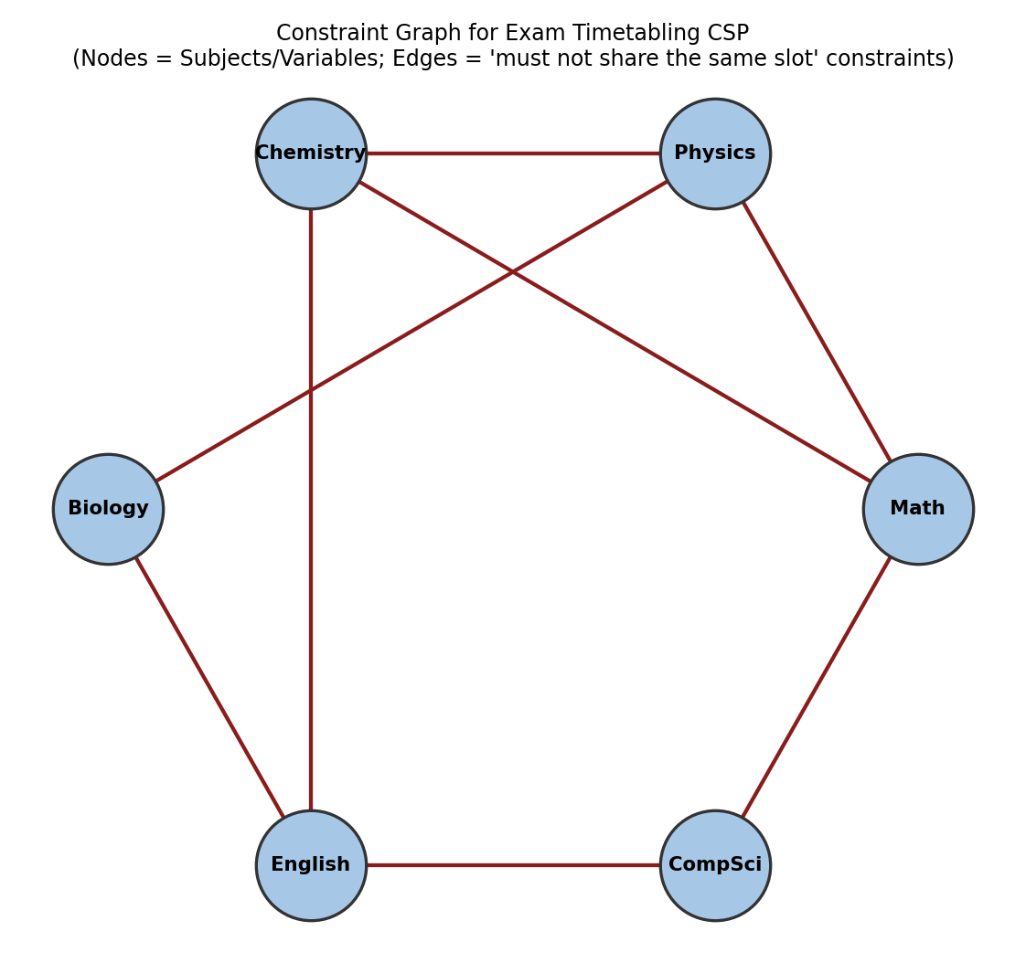
Figure 3.1: Constraint graph for the exam timetabling CSP. Each node is a subject (variable); each edge denotes a constraint that the two connected subjects must not be scheduled in the same slot.

6. Variables, Domains, and Constraints (Applicable for CSP problems)
Element | Details
Variables | Math (M), Physics (P), Chemistry (C), Biology (B), English (E), Computer Science (CS)
Domain (each variable) | {Slot 1, Slot 2, Slot 3}
Constraints (conflicting pairs — must differ) | M–P, M–C, P–C, P–B, C–E, B–E, E–CS, CS–M
Constraint type | Binary, not-equal constraints: value(X) ≠ value(Y) for every conflicting pair (X, Y)

7. Heuristic Function (Applicable for Informed Search)
Not Applicable in the classic sense of a numeric distance heuristic h(n) — CSPs use ordering heuristics instead of a goal-distance estimate. The two ordering heuristics used here are:
- Minimum Remaining Values (MRV): choose the unassigned variable with the fewest legal values remaining in its domain, to detect failure as early as possible.
- Forward Checking: after each assignment, immediately prune values from neighbouring unassigned variables' domains that would violate a constraint, tightening the search space proactively rather than discovering conflicts later.

8. Algorithm Design / Pseudocode
function BACKTRACKING-SEARCH(csp):
return BACKTRACK({}, csp)

function BACKTRACK(assignment, csp):
if assignment is complete: return assignment
var <- SELECT-UNASSIGNED-VARIABLE(csp) // MRV heuristic
for each value in ORDER-DOMAIN-VALUES(var, assignment, csp):
if value is consistent with assignment:
add {var = value} to assignment
inferences <- FORWARD-CHECK(csp, var, value)
if inferences != FAILURE:
add inferences (pruned domains) to csp
result <- BACKTRACK(assignment, csp)
if result != FAILURE: return result
remove {var = value} from assignment
restore pruned domains (undo inferences)
return FAILURE

function SELECT-UNASSIGNED-VARIABLE(csp):
return variable with the smallest current domain size (MRV)

function FORWARD-CHECK(csp, var, value):
for each neighbour Y of var that is unassigned:
remove value from domain(Y) if it violates the var-Y constraint
if domain(Y) becomes empty: return FAILURE
return list of pruned values (for later restoration)

9. Flowchart / Algorithm Diagram
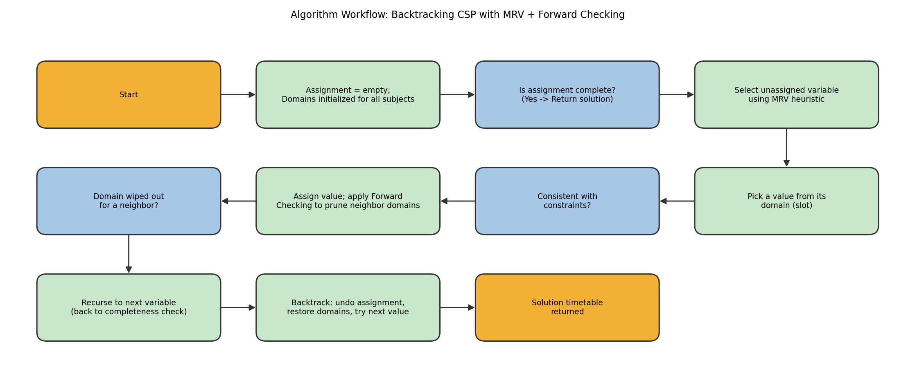
Figure 3.2: Algorithm workflow for Backtracking CSP with MRV variable ordering and Forward Checking.

10. Working / Execution Trace
Degree of each subject (number of conflicts) at the start: Math=3 (P,C,CS), Physics=3 (M,C,B), Chemistry=3 (M,P,E), English=3 (C,B,CS), Biology=2 (P,E), CS=2 (E,M). All start with domain size 3, so MRV ties are broken using the most-constraining-variable (highest degree) heuristic — Math is picked first.
Step | Variable Assigned (MRV) | Value | Forward-Checking Effect (domains pruned)
1 | Math | Slot 1 | Physics, Chemistry, CS lose Slot 1 from their domains
2 | Physics (domain now {2,3}) | Slot 2 | Chemistry, Biology lose Slot 2
3 | Chemistry (domain now {3}) | Slot 3 | English loses Slot 3 (Math already removed Slot1 from CS/Chem earlier)
4 | English (domain now {1,2}) | Slot 1 | Biology, CS lose Slot 1
5 | Biology (domain now {3}) | Slot 3 | No further neighbours unassigned
6 | CS (domain now {2,3}) | Slot 2 | Assignment complete — all constraints satisfied
Final Timetable: Math→Slot 1, Physics→Slot 2, Chemistry→Slot 3, English→Slot 1, Biology→Slot 3, CS→Slot 2
At every step, MRV picked the subject with the smallest remaining domain (breaking ties by picking the most-constraining subject), and Forward Checking immediately shrank neighbouring domains, so no dead end or backtracking was needed in this trace — a direct illustration of why these two techniques together produce a far more efficient search than naive backtracking, which might have assigned subjects in an arbitrary order and discovered the Chemistry–English or Biology–English conflicts only after several wasted assignments.

11. Complexity Analysis
- Time Complexity: Worst case O(d^n) for plain backtracking, where d is domain size and n is the number of variables (here 3^6 = 729 possible combinations); MRV and Forward Checking do not change this worst-case bound but drastically reduce the average number of nodes actually explored by pruning inconsistent branches early, as shown in the trace where zero backtracks were required.
- Space Complexity: O(n × d) to store the current domains of all variables during forward checking, plus O(n) for the recursion stack — much cheaper than storing the entire search tree.
- Solution Efficiency: Forward checking's early domain-pruning means constraint violations are detected the moment they become inevitable, rather than only at the point of full assignment, which is the main efficiency gain over naive backtracking.

12. Advantages and Limitations
- Advantage: MRV concentrates search effort on the hardest-to-satisfy variables first, following the fail-first principle and reducing the size of the search tree actually explored.
- Advantage: Forward Checking detects dead ends (empty domains) immediately after an assignment, avoiding wasted exploration of doomed branches.
- Limitation: Forward Checking only looks one step ahead — it does not detect conflicts among not-yet-assigned neighbouring variables (arc inconsistency further downstream), which a stronger technique such as full Arc Consistency (AC-3) would catch.
- Limitation: In highly connected constraint graphs (many overlapping subjects), even MRV + Forward Checking may still require some backtracking, and worst-case complexity remains exponential.

13. Conclusion
Modelling the exam timetable as a CSP with subjects as variables, exam slots as domains, and shared-student pairs as not-equal constraints allowed a clean, systematic solution using Backtracking Search. The MRV heuristic and Forward Checking together produced a conflict-free timetable without any backtracking in this trace, demonstrating substantial efficiency gains over naive backtracking. For larger, more densely connected universities (more subjects, more shared students), the design could be further improved by adding full Arc Consistency (AC-3) preprocessing or the Least Constraining Value heuristic for value ordering, and by exploring local search techniques such as Min-Conflicts for very large timetabling instances.

Question 4: Minimax and Alpha–Beta Pruning for Game Playing
"Design the Minimax algorithm for the given game tree to determine the best move for the MAX player. Then apply Alpha–Beta Pruning to the same tree and indicate which nodes are pruned. Compare the number of nodes evaluated before and after pruning."

1. Problem Statement
Two players, MAX and MIN, alternate turns in a zero-sum game represented by a game tree. Each leaf node holds a utility value from MAX's perspective. The task is to determine the best move for MAX at the root by computing the minimax value of the tree, and then to show how Alpha–Beta Pruning can compute the same result while evaluating fewer nodes.

2. Problem Analysis
- Initial State: The root node A, where it is MAX's turn to move.
- Goal State: Not a single terminal state, but a decision — the child of the root that leads to the highest guaranteed minimax value for MAX.
- State Space: A game tree of depth 3 with branching factor 2 at every level (root A, MIN level {B, C}, MAX level {D, E, F, G}, and 8 leaf nodes with utility values).
- Assumptions: Both players play optimally — MAX always maximises the utility, MIN always minimises it; the game tree and all leaf utilities are fully known in advance (perfect information, deterministic game).
- Constraints: A move can only be chosen from the tree structure given; the algorithm must return the correct minimax value for the root and the optimal move to reach it.

3. AI Technique Selection
The selected technique is the Minimax algorithm, followed by Alpha–Beta Pruning as an optimisation that computes an identical result while visiting fewer nodes.

4. Justification of Algorithm
- Minimax is the standard technique for two-player, zero-sum, perfect-information games because it correctly accounts for an adversary who is actively trying to minimise MAX's outcome, unlike single-agent search algorithms (Greedy, A*) which assume a passive/cooperative environment.
- Compared to a naive exhaustive evaluation of every leaf independently, Minimax structures the evaluation recursively bottom-up, which is both correct and efficient to implement.
- Alpha–Beta Pruning is added because plain Minimax must examine every leaf of the tree (exponential in depth), which becomes prohibitively expensive for real games (e.g., chess); Alpha–Beta provably returns the exact same root decision while skipping branches that cannot possibly influence the final result, making deeper search feasible within the same time budget.

5. State Space Representation
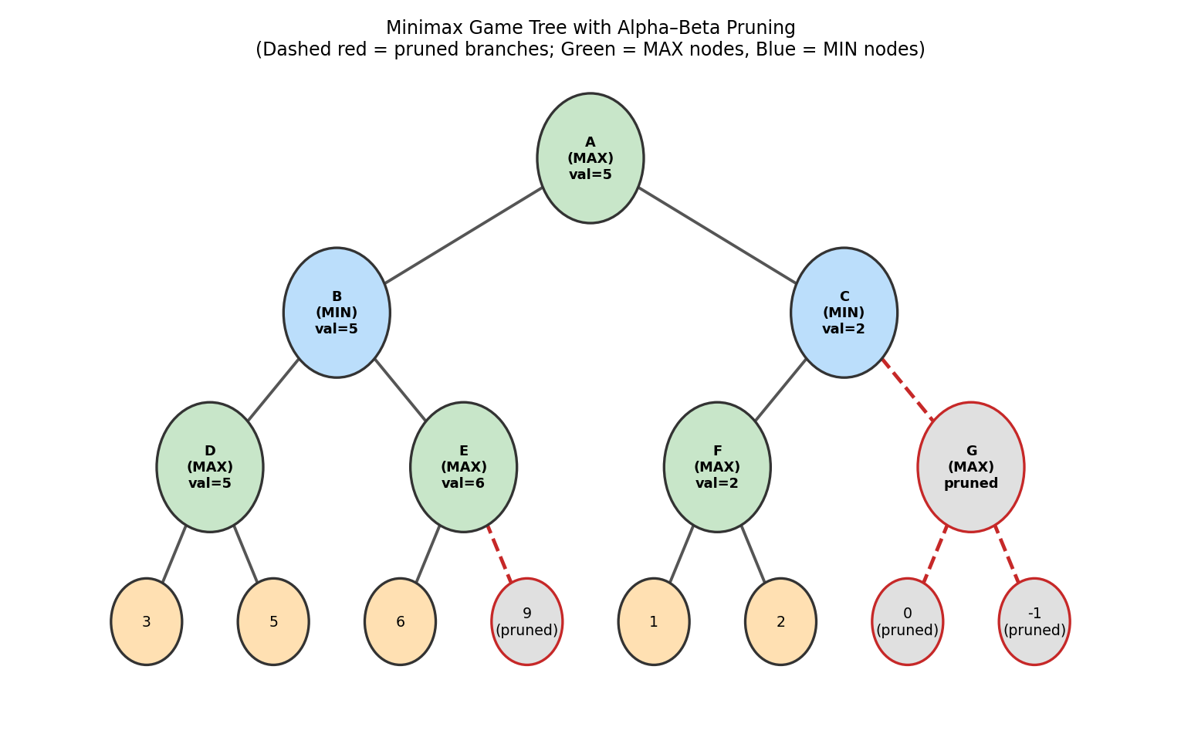
Figure 4.1: Game tree showing Minimax values at every node. Dashed red branches indicate nodes pruned by Alpha–Beta Pruning; green = MAX nodes, blue = MIN nodes, orange = leaf utility values.

6. Variables, Domains, and Constraints (Applicable for CSP problems)
Not Applicable – this is an adversarial game-tree search problem, not a Constraint Satisfaction Problem.

7. Heuristic Function (Applicable for Informed Search)
Not Applicable in the classic informed-search sense — Minimax uses exact backed-up utility values from the leaves rather than an estimated distance to a goal. (In large real games, a static evaluation function is used to score non-terminal nodes at a cut-off depth, but for this fully specified small tree, exact leaf utilities are used directly.)

8. Algorithm Design / Pseudocode
function ALPHA-BETA-SEARCH(node):
return MAX-VALUE(node, -infinity, +infinity)

function MAX-VALUE(node, alpha, beta):
if node is a leaf: return utility(node)
value <- -infinity
for each child of node:
value <- max(value, MIN-VALUE(child, alpha, beta))
alpha <- max(alpha, value)
if alpha >= beta:
break // beta cut-off: prune remaining children
return value

function MIN-VALUE(node, alpha, beta):
if node is a leaf: return utility(node)
value <- +infinity
for each child of node:
value <- min(value, MAX-VALUE(child, alpha, beta))
beta <- min(beta, value)
if alpha >= beta:
break // alpha cut-off: prune remaining children
return value

9. Flowchart / Algorithm Diagram
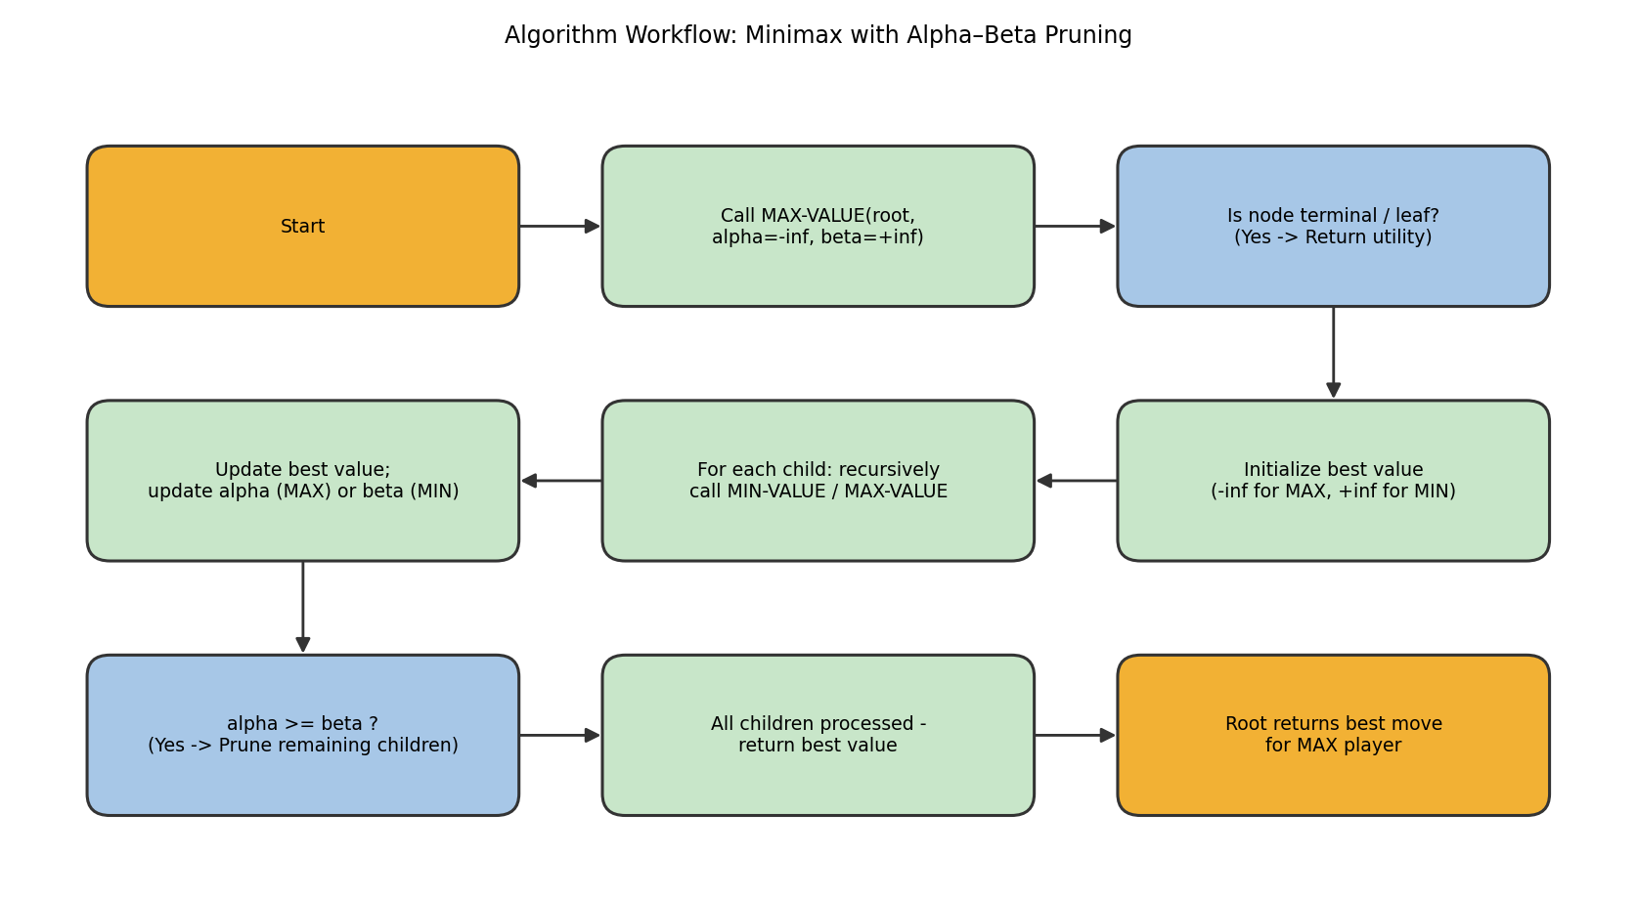
Figure 4.2: Algorithm workflow for Minimax with Alpha–Beta Pruning.

10. Working / Execution Trace
Tree structure: Root A (MAX) → B, C (MIN). B → D, E (MAX); C → F, G (MAX). Leaves: D→{3,5}, E→{6,9}, F→{1,2}, G→{0,–1}.
Step A – Plain Minimax (bottom-up, no pruning):
Node | Type | Computation | Value
D | MAX | max(3, 5) | 5
E | MAX | max(6, 9) | 9
B | MIN | min(D=5, E=9) | 5
F | MAX | max(1, 2) | 2
G | MAX | max(0, –1) | 0
C | MIN | min(F=2, G=0) | 0
A | MAX | max(B=5, C=0) | 5
Plain Minimax evaluates all 15 nodes (8 leaves + 7 internal nodes) and determines the best move for MAX is to go toward B (value 5).
Step B – Alpha–Beta Pruning (same tree):
Node Visited | α (alpha) | β (beta) | Outcome
A (MAX) enters | −∞ | +∞ | Calls B
B (MIN) enters | −∞ | +∞ | Calls D
D: leaf 3, leaf 5 | − | − | D = max(3,5) = 5
B updates β = 5 | −∞ | 5 | Calls E with α=−∞, β=5
E: leaf 6 | 6 | 5 | α(6) ≥ β(5) → PRUNE leaf 9
E returns 6; B = min(5,6) = 5 | − | − | B = 5; back to A, α = 5
C (MIN) enters | 5 | +∞ | Calls F with α=5, β=+∞
F: leaf 1, leaf 2 | 5 | +∞ | F = max(1,2) = 2
C updates β = 2 | 5 | 2 | α(5) ≥ β(2) → PRUNE entire G subtree
C returns 2 (G never visited) | − | − | A = max(B=5, C=2) = 5
Nodes Pruned: Leaf value 9 (under E), and the entire subtree under G (node G itself plus leaves 0 and –1) — 4 nodes in total.
Best Move for MAX: Move toward B, achieving the guaranteed minimax value of 5 — identical to plain Minimax, confirming Alpha–Beta Pruning never changes the result.

11. Complexity Analysis — Nodes Evaluated Before vs After Pruning
Metric | Plain Minimax | Alpha–Beta Pruning
Leaf nodes evaluated | 8 (all leaves) | 5 (3, 5, 6, 1, 2)
Internal nodes visited | 7 (A,B,C,D,E,F,G) | 6 (A,B,C,D,E,F — G never entered)
Total nodes evaluated | 15 | 11
Nodes saved by pruning | — | 4 (≈27% reduction on this tree)
- Time Complexity: Plain Minimax is O(b^d) (b = branching factor, d = depth); here b=2, d=3, giving 2^3 = 8 leaves, matching the trace. Alpha–Beta Pruning has the same worst-case O(b^d) but with a best-case (perfect move ordering) of O(b^(d/2)), effectively allowing search to twice the depth in the same time budget.
- Space Complexity: Both algorithms are O(bd) (or O(d) for a depth-first implementation storing only the current path), since only one path of the tree needs to be held in memory at a time.
- Solution Efficiency: On this tree, Alpha–Beta pruned 4 of 15 nodes (≈27%) while returning the exact same root value (5) and the same best move, directly demonstrating the efficiency gain without any loss of correctness.

12. Advantages and Limitations
- Advantage: Minimax guarantees the optimal move against a perfectly rational adversary by correctly propagating adversarial (minimising) behaviour up the tree.
- Advantage: Alpha–Beta Pruning returns exactly the same decision as plain Minimax while evaluating fewer nodes, with pruning effectiveness improving further when children are explored in a good move-ordering (best moves first).
- Limitation: Both algorithms assume the opponent plays optimally; against a weaker or non-optimal opponent, Minimax may be overly conservative and miss opportunities to exploit mistakes.
- Limitation: For real games with enormous branching factors and depths (e.g., chess, Go), even Alpha–Beta Pruning cannot search to the terminal states, requiring a depth cut-off with a static evaluation function, which introduces approximation error.

13. Conclusion
Minimax correctly determined that MAX's best move leads to a guaranteed value of 5 by evaluating all 15 nodes of the tree. Applying Alpha–Beta Pruning to the same tree produced the identical result (value 5, same best move) while evaluating only 11 nodes, pruning the E node's second leaf (9) and the entire G subtree. This confirms that Alpha–Beta Pruning is a pure efficiency optimisation with no loss of decision quality. For larger game trees, this design could be further improved with move-ordering heuristics (e.g., trying historically strong moves first) to maximise the pruning rate, and with iterative deepening combined with a depth-limited evaluation function for practical real-time game play.

Question 5: Online Search Agent for a Dynamic Warehouse Environment
"A warehouse robot operates in a dynamic environment where obstacles may appear unexpectedly. Design an intelligent search strategy using either Local Search or an Online Search Agent. Explain how the algorithm adapts to environmental changes and compare its performance with informed search algorithms."

1. Problem Statement
A warehouse robot must navigate from a start location S to a goal location G within a grid-based warehouse. Some obstacles (shelves, machinery) are known in advance (static), but other obstacles (a person, a dropped pallet) may appear unpredictably while the robot is moving (dynamic). The robot cannot fully re-plan from scratch using a global map every time an obstacle appears, so it must sense its immediate surroundings and adapt its path in real time as it moves.

2. Problem Analysis
- Initial State: The robot's starting grid cell S.
- Goal State: The target grid cell G (e.g., a packing station).
- State Space: All reachable, unobstructed grid cells in the warehouse.
- Assumptions: The robot has only local sensing (it can detect obstacles in its immediate vicinity, not the whole warehouse at once); the environment is only partially known in advance (static obstacles are known; dynamic obstacles are not); actions have deterministic outcomes once taken.
- Constraints: The robot must never move into a currently blocked cell; it must reach the goal while re-planning on the fly whenever a previously assumed-clear cell becomes blocked.

3. AI Technique Selection
The selected technique is an Online Search Agent using the Learning Real-Time A* (LRTA*) strategy — a form of local search that interleaves computation (deciding the next best move) with actual movement in the real environment, updating its own heuristic estimates as it learns more about the environment.

4. Justification of Algorithm
- Offline informed search algorithms such as A* or Greedy Best-First Search assume the entire state space (including all obstacles) is known before the search begins; this assumption is violated here because obstacles can appear unexpectedly, meaning any full plan computed in advance could become invalid mid-execution.
- An Online Search Agent is appropriate because it only needs to decide its next action based on the current, locally-sensed state, and can incorporate newly discovered information (a blocked cell) immediately, without needing to reconsider distant unexplored regions of the map.
- LRTA* specifically is chosen over pure reactive/greedy local movement because it maintains and updates a heuristic value h(s) for each state it visits, allowing it to ‘learn’ that a region is a dead end or costly and avoid repeating the same mistake, which a memoryless local search would not do.
- Compared to Hill-Climbing (a simpler local search), LRTA* is less prone to getting permanently stuck, since its heuristic updates allow it to ‘back away’ from a locally bad region over repeated visits, though it can still revisit cells before finding the best route (see Limitations).

5. State Space Representation
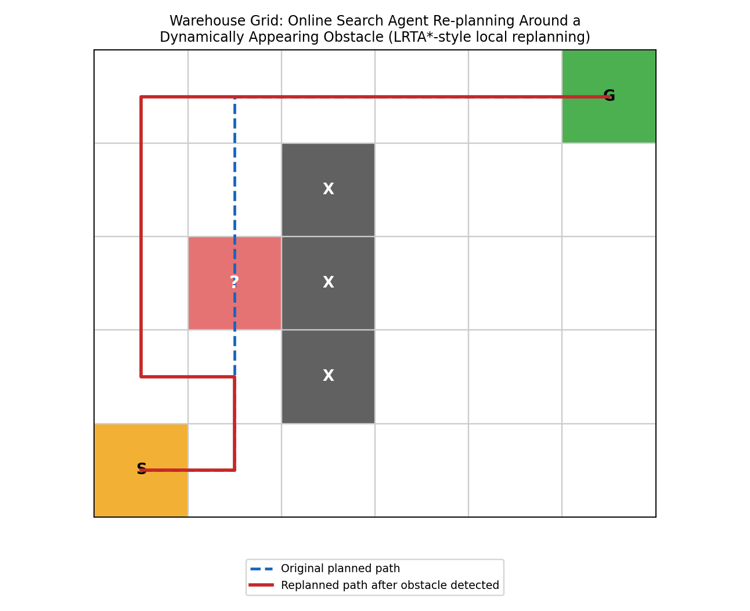
Figure 5.1: Warehouse grid showing static obstacles (dark grey), the start (S) and goal (G) cells, and a dynamically appearing obstacle (red, marked '?'). The dashed blue line is the originally planned route; the solid red line is the robot's actual replanned route after locally sensing the new obstacle.

6. Variables, Domains, and Constraints (Applicable for CSP problems)
Not Applicable – this is an online/local search problem over a state space, not a Constraint Satisfaction Problem.

7. Heuristic Function (Applicable for Informed Search)
h(n) is initialised as the Manhattan distance from grid cell n to the goal G (an admissible estimate on a grid where only horizontal/vertical moves are allowed). Unlike offline A*, in LRTA* this value is not fixed — it is updated online each time the agent visits a state, based on the actual cost experienced to move to a neighbour plus that neighbour's current heuristic estimate:
h(s) <- max( h(s), min over neighbours n of [ cost(s, n) + h(n) ] )
This update rule ensures the heuristic only ever increases (never decreases below its admissible initial value), progressively ‘learning’ more accurate distance estimates as the robot explores, particularly around newly discovered obstacles.

8. Algorithm Design / Pseudocode
function LRTA-STAR-AGENT(s_current, goal, sensors):
// result table stores previously taken action for each (state) seen
// H stores the agent's learned heuristic estimates, initialised via Manhattan distance
if s_current == goal:
return STOP
if s_current is a new state (not in H):
H[s_current] <- MANHATTAN-DISTANCE(s_current, goal)
neighbours <- SENSE-LOCAL-ENVIRONMENT(s_current, sensors) // detects obstacles now
for each neighbour n in neighbours:
if n is blocked (obstacle sensed):
remove n from available moves // adapts to dynamic obstacle
if n not in H:
H[n] <- MANHATTAN-DISTANCE(n, goal)
a <- argmin over available neighbour n of [ cost(s_current, n) + H[n] ]
H[s_current] <- max( H[s_current], cost(s_current, a) + H[a] ) // learning update
EXECUTE(a) // physically move the robot
s_current <- a
return LRTA-STAR-AGENT(s_current, goal, sensors) // repeat, adapting each step

9. Flowchart / Algorithm Diagram
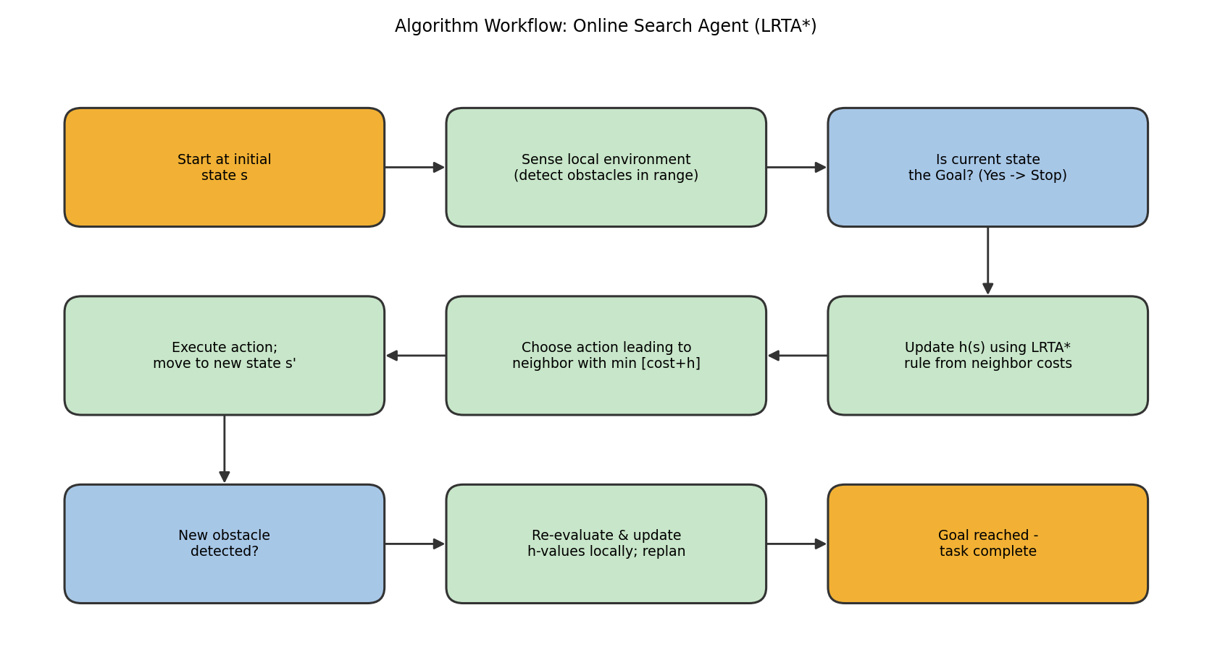
Figure 5.2: Algorithm workflow for the Online Search Agent (LRTA*), showing the sense-decide-act-learn loop that enables real-time adaptation to dynamic obstacles.

10. Working / Execution Trace
Referring to Figure 5.1: the robot initially plans (using its currently known static obstacles at column x=2) a route S → (1,0) → (1,1) → (1,2) → (1,3) → (1,4) → (2,4) → (3,4) → (4,4) → G.
Step | Robot State | Sensed Event | Adaptation
1–3 | Moves S → (1,0) → (1,1) | No obstacle sensed yet | Continues along the originally planned route
4 | At (1,1), senses ahead | New obstacle appears at (1,2) (not known in advance) | Updates H(1,1) upward; removes (1,2) from available moves
5 | Re-decides at (1,1) | Neighbour (0,1) has lowest cost+H after update | Moves to (0,1) instead — local replanning, not a full re-plan
6–9 | Moves (0,1)→(0,2)→(0,3)→(0,4) | No further obstacles sensed | Continues toward goal along the detour
10–13 | Moves (0,4)→(1,4)→(2,4)→(3,4)→(4,4)→G | Rejoins the original planned route | Reaches goal G successfully
This trace shows the defining property of an online search agent: the robot does not stop and recompute a brand-new global plan when it senses the obstacle at (1,2); it only updates its local heuristic values and picks the best next step from its current position, then continues — exactly the sense–decide–act–learn cycle in the pseudocode and Figure 5.2.

11. Complexity Analysis
- Time Complexity: In the worst case, LRTA* can revisit a state multiple times while its heuristic values converge to their true costs, giving a complexity that depends on the number of states and how far the initial heuristic is from the true cost; in the best case (heuristic close to accurate, few dynamic changes), it behaves close to O(n) for n reachable cells, as seen in this trace where only one re-plan was needed.
- Space Complexity: O(n) to store the learned heuristic table H(s) for visited states, which is generally much smaller than storing an entire pre-computed global plan, since only visited/explored cells need entries.
- Solution Efficiency: The robot reached the goal with only one local replanning event triggered directly by the newly sensed obstacle, avoiding the cost of a full-map re-search each time the environment changed — the key efficiency advantage of online search in dynamic environments.

12. Advantages and Limitations
- Advantage: Naturally adapts to dynamic, partially observable, or initially unknown environments, since decisions are based on current local sensing rather than a static, pre-computed global plan.
- Advantage: Low memory footprint compared to storing/recomputing a full map-wide plan after every environmental change, and it 'learns' over repeated traversals of the same warehouse, improving over time.
- Limitation: Not guaranteed to find the globally shortest path on the first attempt — the robot may take detours (as seen going via column 0 instead of a possibly shorter alternative) before its heuristic values converge.
- Limitation: Compared to offline informed search (A*, Greedy Best-First Search) which computes a full, cost-optimal plan in one pass when the map is fully known, the online agent trades guaranteed optimality and one-shot planning for real-time adaptability; it can also revisit the same states multiple times, which A* on a static map would never do.

13. Conclusion
The Online Search Agent using LRTA* enabled the warehouse robot to reach its goal despite an unexpected obstacle appearing mid-route, by sensing locally, updating its heuristic estimates, and replanning only the immediate next step rather than recomputing a full global route. This adaptability makes it clearly superior to offline informed search algorithms such as A* or Greedy Best-First Search in genuinely dynamic environments, where those algorithms would require an expensive full re-plan (or would fail outright) every time a new obstacle appeared. Where the environment is largely static with only occasional changes, a hybrid approach — running A* for the bulk of the route and invoking local replanning (as demonstrated here) only in the affected region when a change is sensed — would combine the optimality of offline search with the responsiveness of online search, and is a natural direction for improving this design further.

